

PROJECT REPORT

ON

**STUDENT REGISTRATION SYSTEM**

Group Members

**AMDULHARIS YUNUH - 591431016**

**MUHAMMADATIP WAEHAMA – 591431008**

Lecturer

**AJ. SUAIDA BUENAE**

Course

**IT2301-302 Object Oriented Programming**

1st Semester, 2018

Date: 21th April 2018

Department of Information Technology, Faculty of Science and Technology

**FATONI UNIVERSITY**

**Acknowledgement**

I would like to express my deepest appreciation to all those who provided me the possibility to complete this report.  A special gratitude I give to our project lecturer , Ms.Suaida Buenae , who give the suggestion to our project.

I would like to express my gratitude towards our group Amdulharis Yunuh and Muhammadatip Waehama whose intent the project for the best performance.

Our thanks and appreciations also go to my colleague in developing the project and people who have willingly helped me out with their abilities. If any some mistakes in our project we have to say apologize .

**Summary**

This report includes program output of the Student Registration System. The methods include planning, topic discussion and selection and designing an application using Java Jframe. In the process, we discussed topic and find out that Student Registration System is the suitable topic to get more developments. The Student Registration System have an admin to control and take care of registration. However, the program itself still lacks a better and enhanced feature such as displaying the file images.

Table of Contents

**System Overview** 3

**System database and tables** 4

**The System/ application** 6

**Conclusion** 14

**References** 15

**Appendix** 16

# **System Overview**

## 

**System Description**

The Student Registration System allows admin enter to the student’s information such as the marks, the address and other and it’s will be saved into the database. The admin is able to add marks or delete, add or delete the students list, edit the student information. Furthermore, only admin is allowed to access all the information of students records by entering a username and password provided. In addition, admin can search, update or delete the student records.

**Goals and Objectives of the people using the System**

Firstly, Student Registration System can control by admin. In addition, allows the lecturer in the university control the information of their students. Finally, the students can only check their information in the Student Registration System such as checking the marks.

**Main Function of the Application**

1. Only admin can search, update or delete in this system.
2. Encrypted with username and password for admin.

# **System database and tables**

**Database:** stdmgdb = Student Registration System

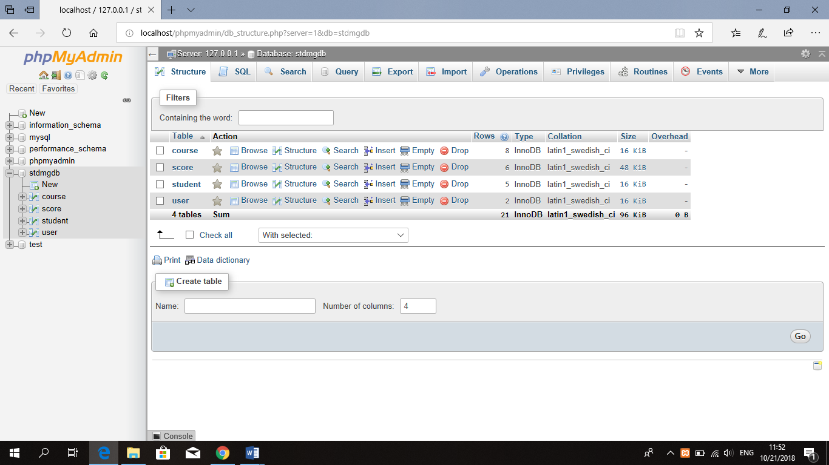

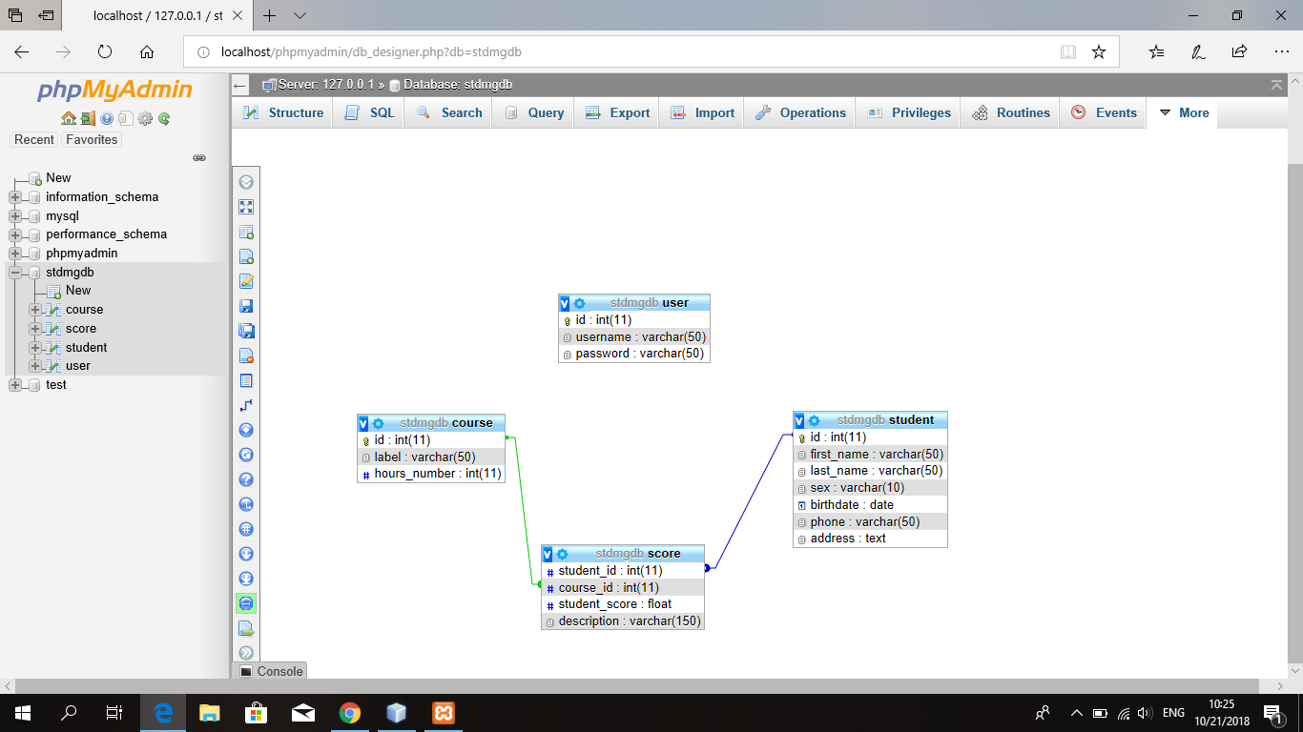

**Table:**

1. Course

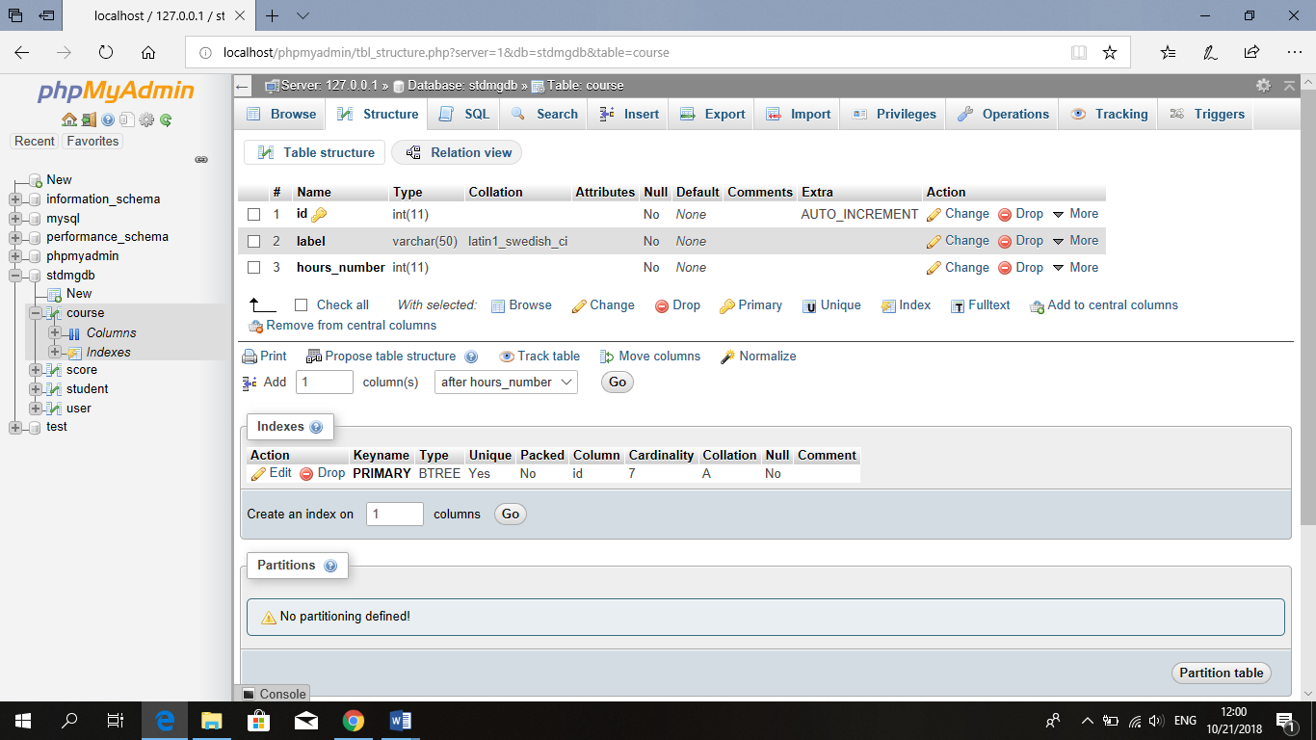

1. Score

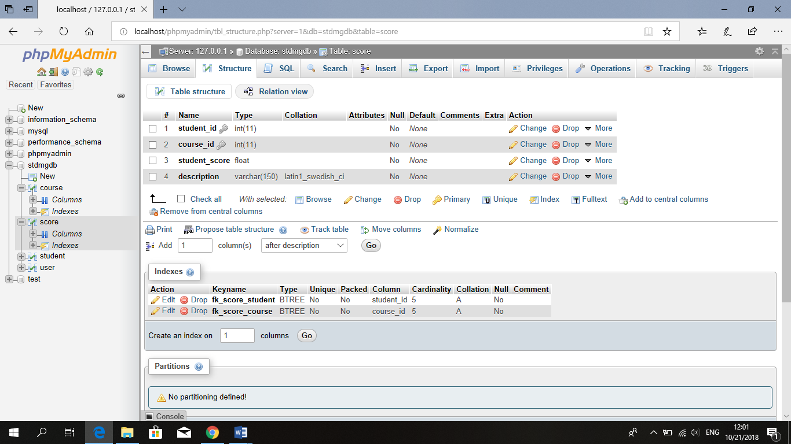

1. Student

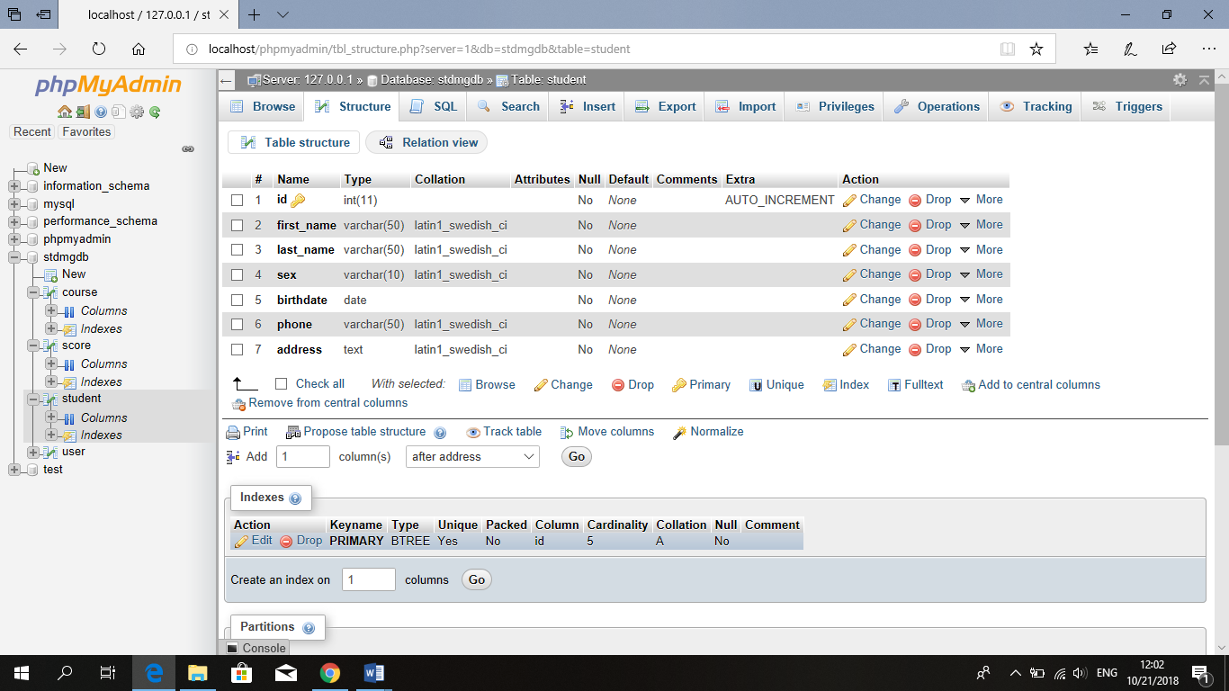

1. user

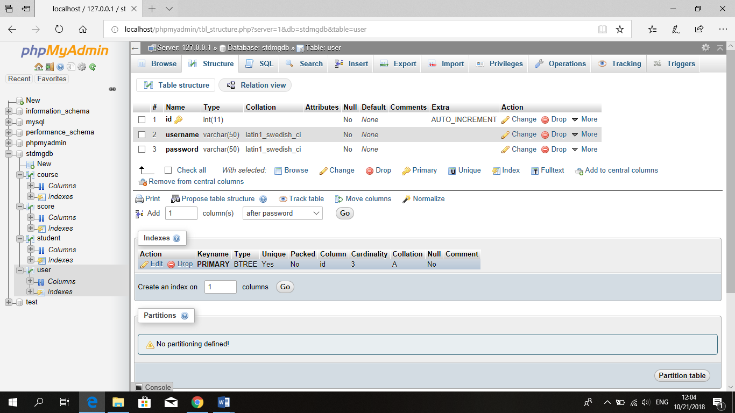

# 

# **The System/ application**

#### **1 - Main Form**

This is the main form we can choose admin or student.

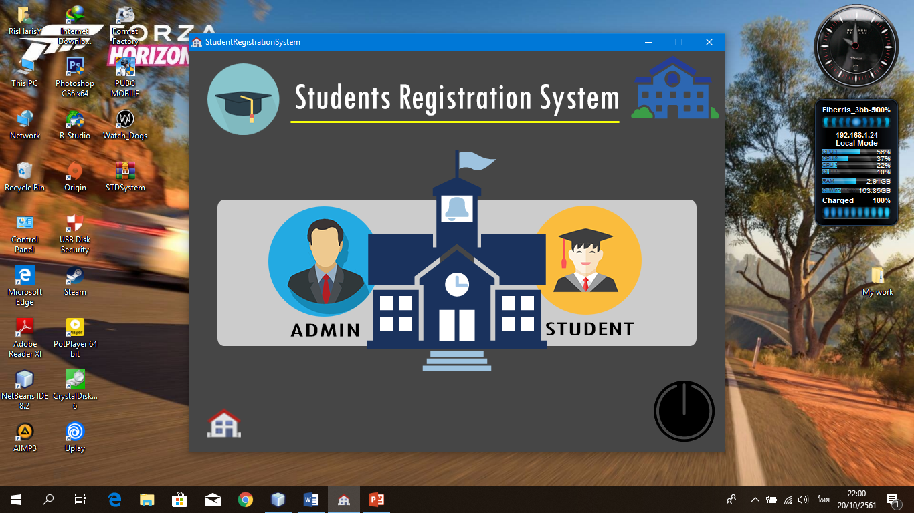

**2 – If choose STUDENT**

This is all student in system by admin edited.

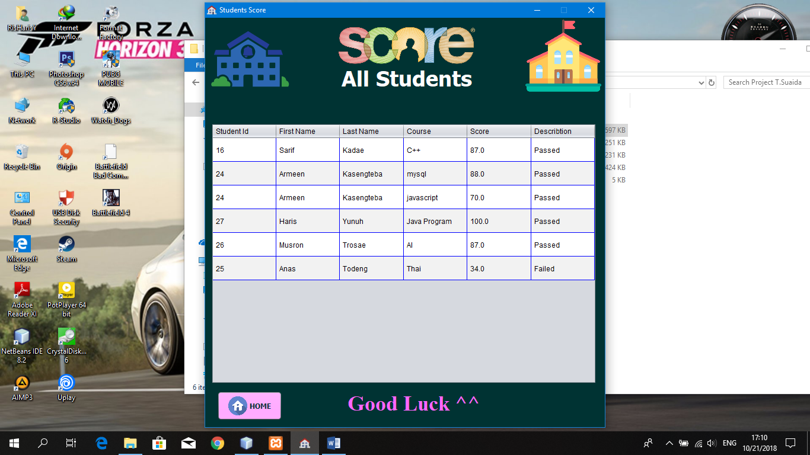

**3 – If choose ADMIN**

This is only user can login system.

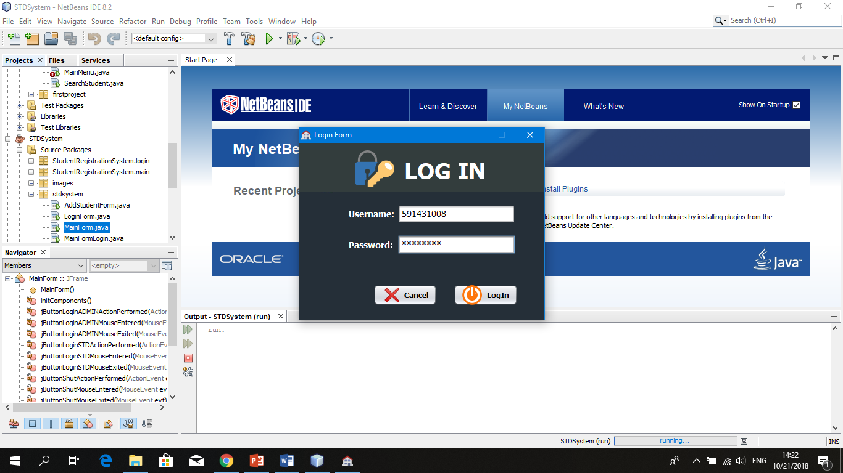

 If username or password are wrong.

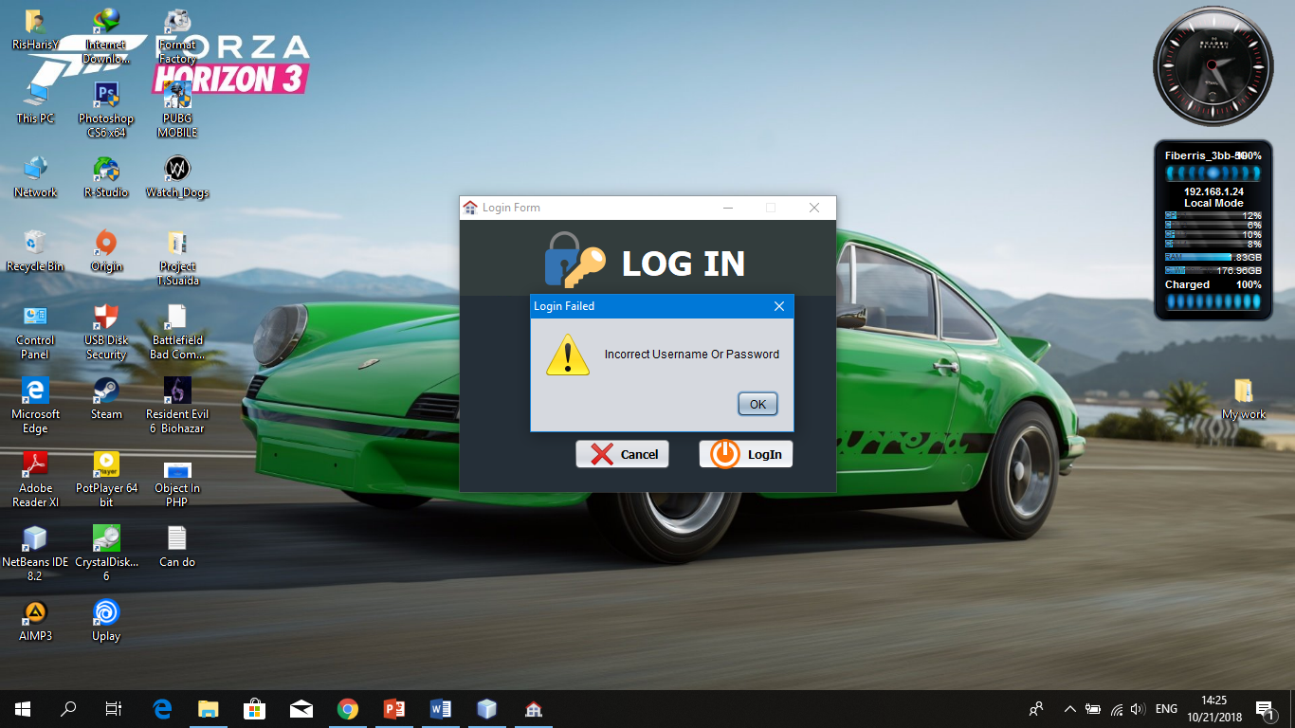

If one or more text fields are empty show asterisk.

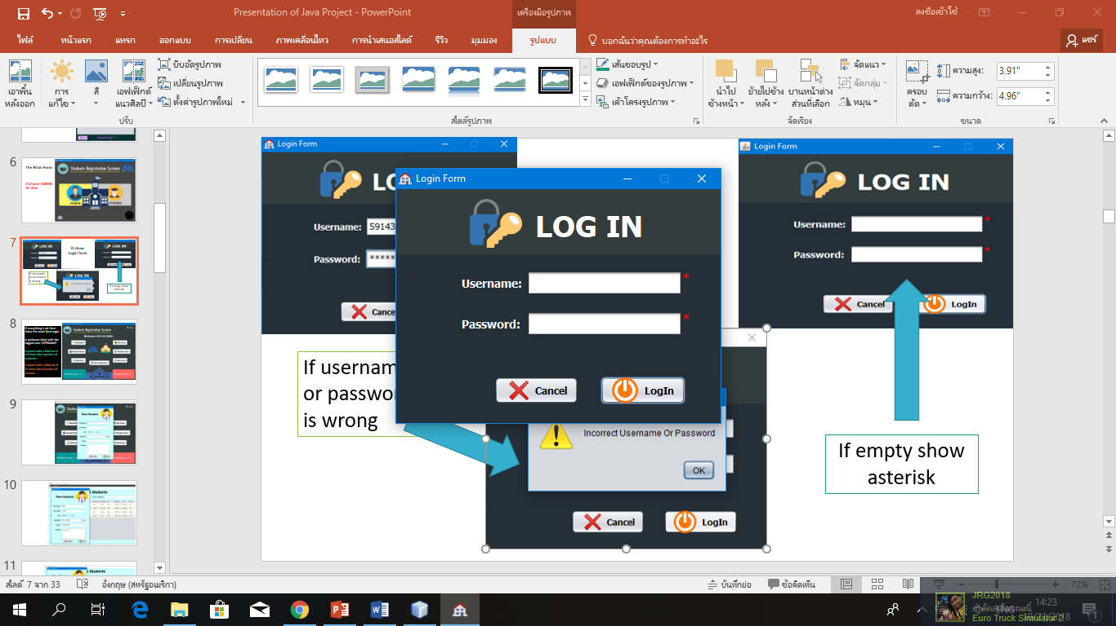

**4 – Main Form Login**

If everything is ok then show the main form login.

A welcome label with the logged user USERNAME .

A panel with a label on it to show total number of students .

A panel with a label on it to show total number of courses .

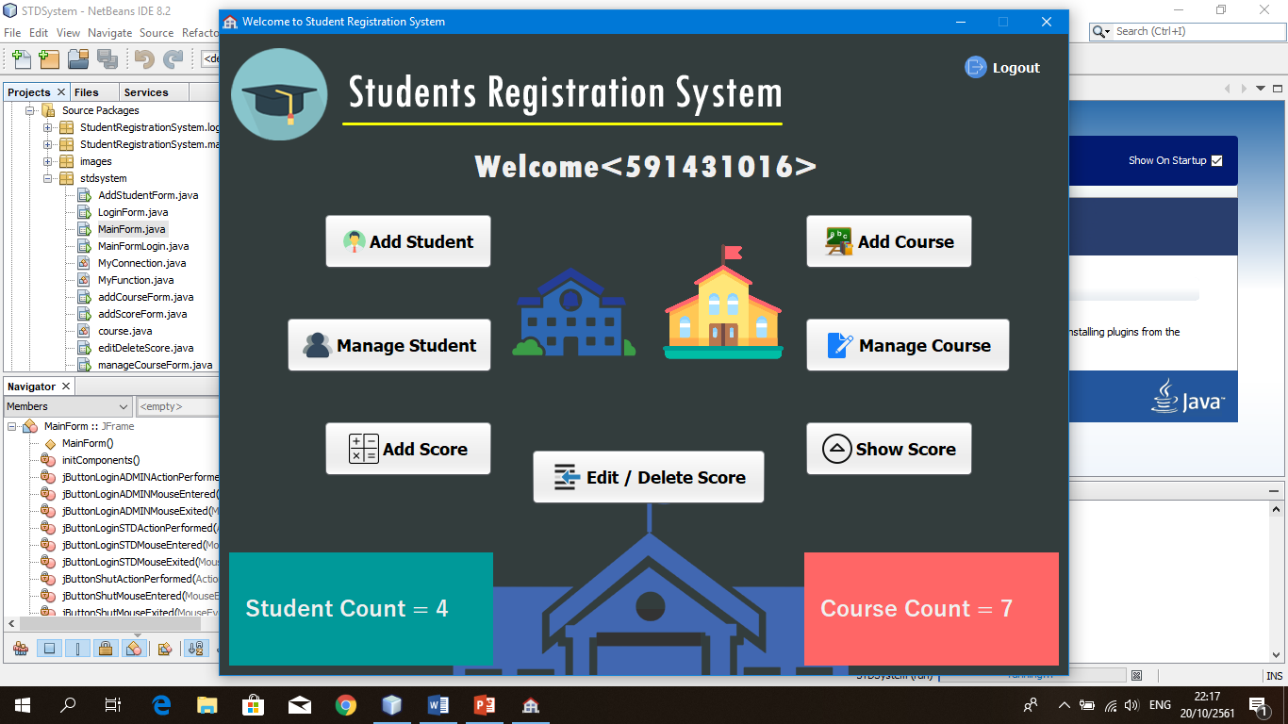

**5 – Add student and Manage Student**

User can add new student, edit student, delete or remove student we call user can control everything.

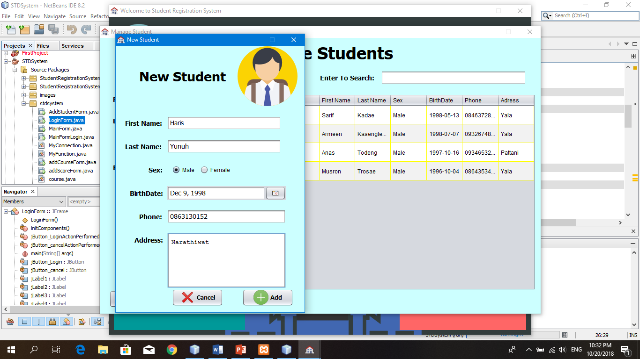

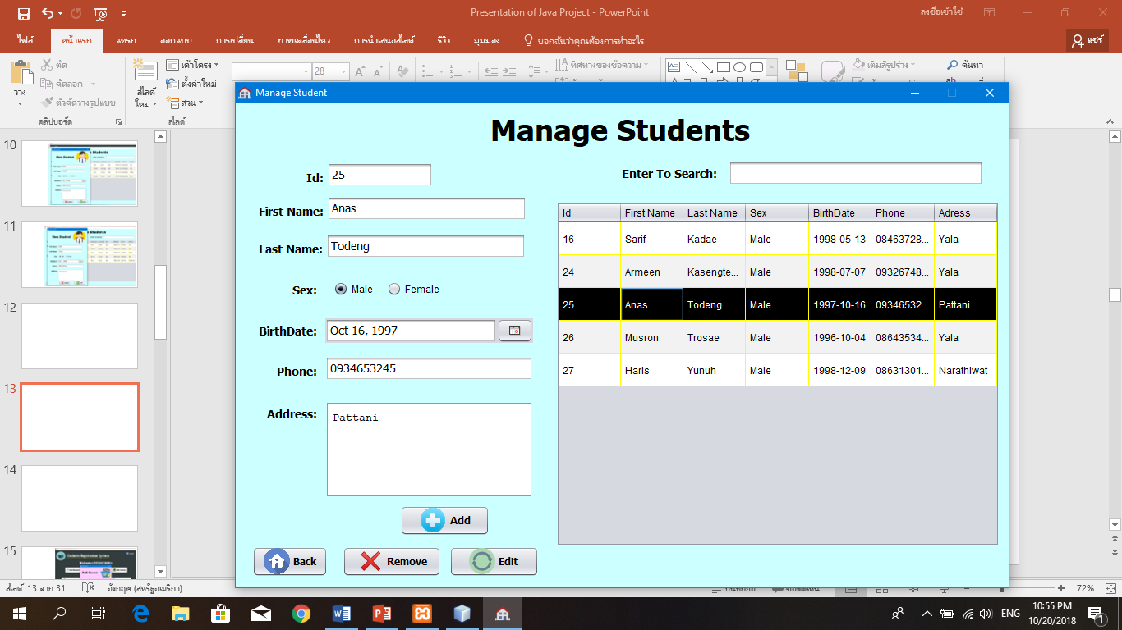

**6 – Add course and Manage course**

User can add new course, edit course, delete or remove course we call user can control everything too.

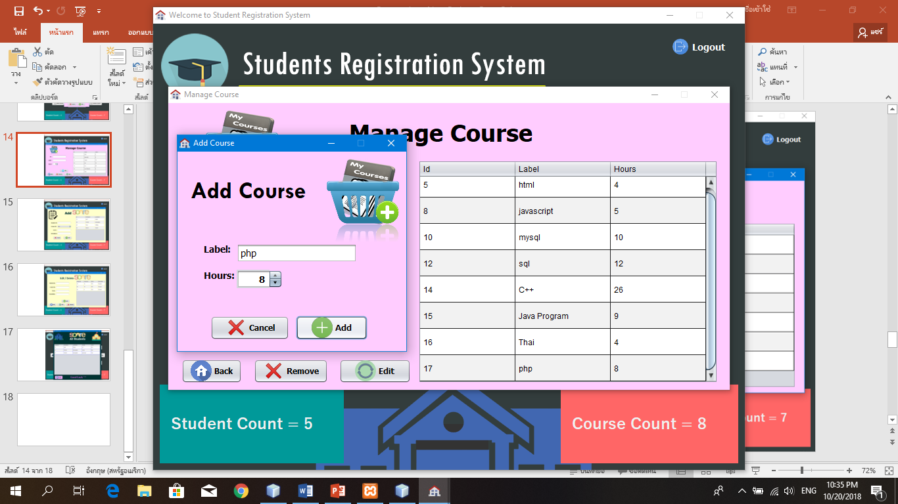

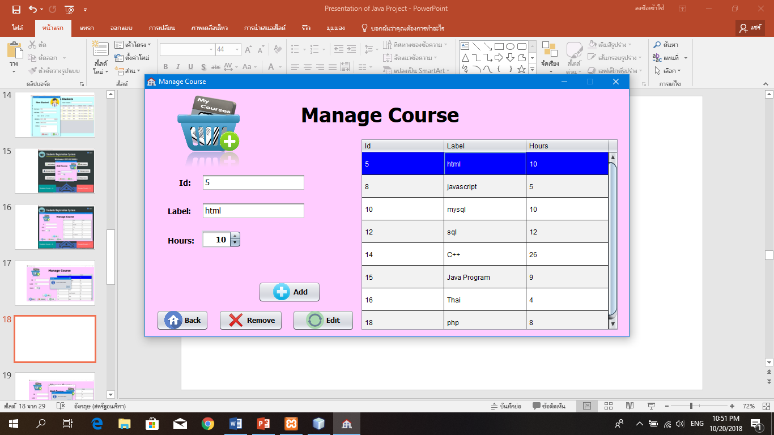

**7 – Add score and Manage score to student**

User can add score to each student, edit score, delete or remove score depend on user.

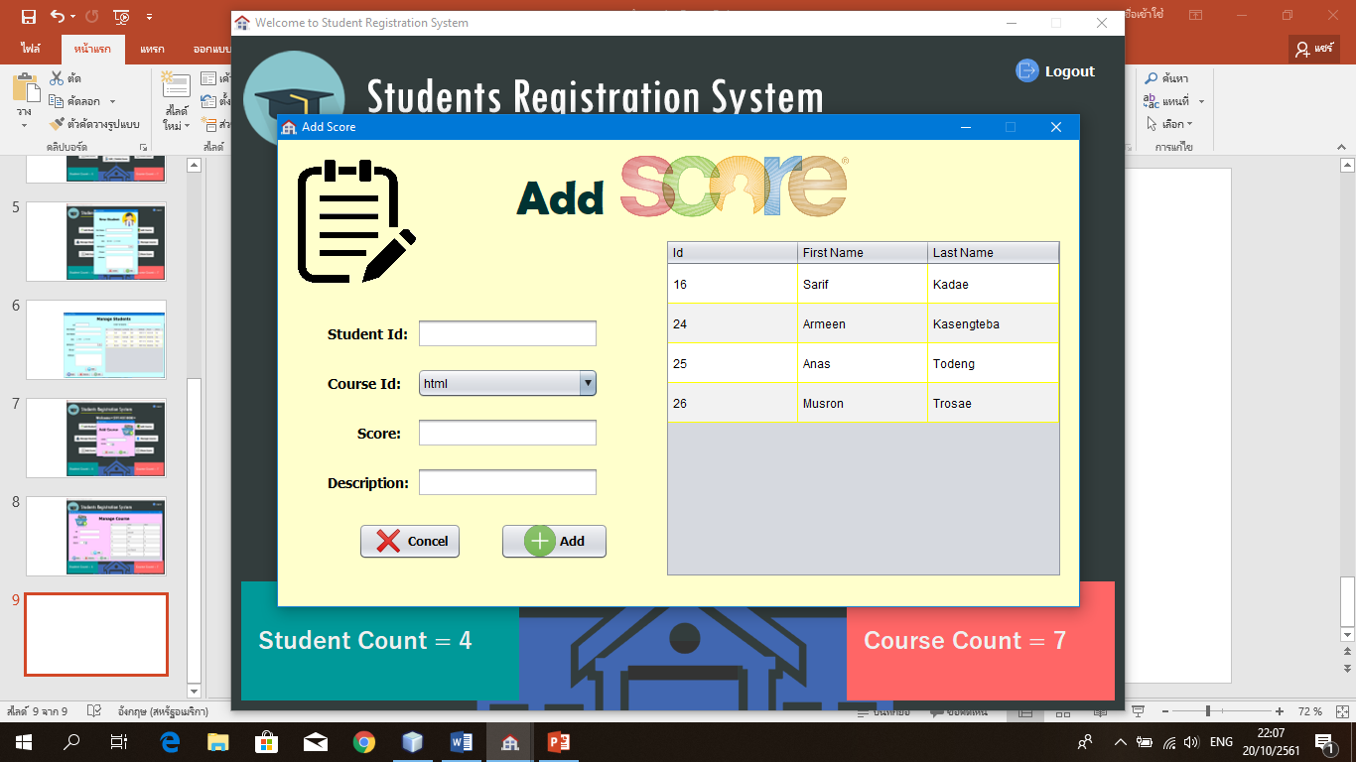

Course id can select depend on user.

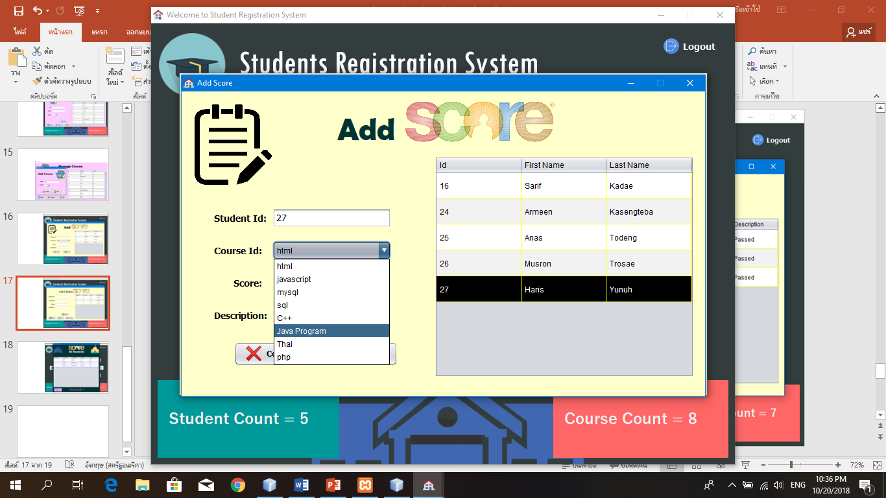

**8 – Edit and Delete Score**

This is user can edit or update score or if no need some score it can delete by user.

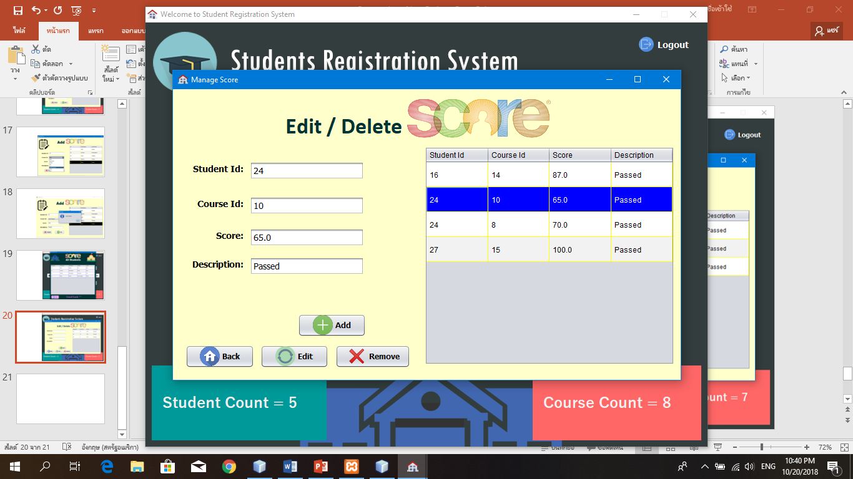

User can update score depend on user.

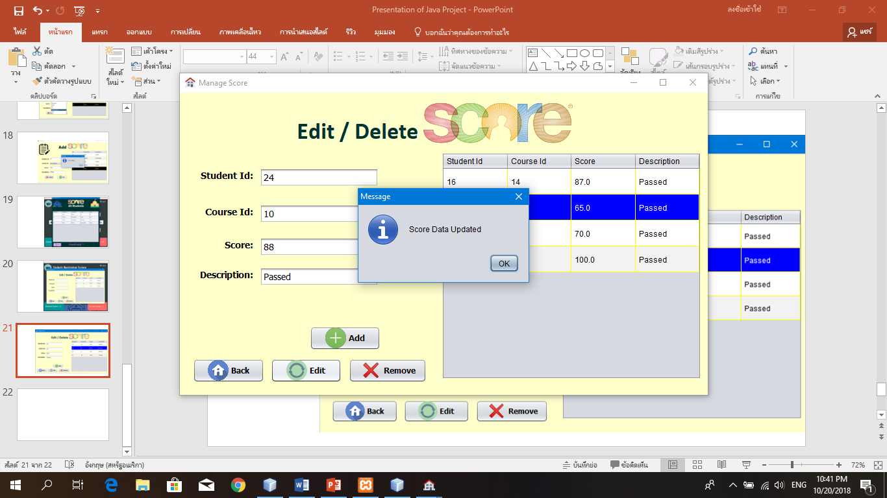

**8 – Show Score all student user added**

This is user added edited then the program can show all.





# **Conclusion**

By making Java Jframe project, our group created the program about student registration system we have many difficulties to do. Firstly, we cannot connect to database in xampp. Secondly, cannot get value from JCalenderBotton to be birthdate into the database and cannot get value in Table from database. Thirdly, we use Program PHOTOSHOP to create interface in java. Finally, we have done our project and study from internet and my friend to help us how to do.

* + Our program application completed. No error, no lack.
  + The program can use in daily life.
  + Our program easy to use and easy to understand.
  + Interface of application is beautiful.
  + Created design by Program Photoshop CS6.

Al-ham-dulillah.

# **References**

Class:

* GUI and MySQL Connection (Presentation slides)

Internet:

* 1bestcsharp: <http://1bestcsharp.blogspot.com/2017/08/java-student-information-system-source-code.html>
* [1BestCsharp blog](https://www.youtube.com/channel/UCS3W5vFugqi6QcsoAIHcMpw): Java And MySQL - How To Insert Update Delete And Display Data In JTable with source code Part 2. [Video file]. Retrieved from <https://www.youtube.com/watch?v=WIMojkwMTa0&t=183s>
* [1BestCsharp blog](https://www.youtube.com/channel/UCS3W5vFugqi6QcsoAIHcMpw): (20 Mar, 2016). Java Project For Beginners Step By Step Using NetBeans And MySQL Database In One Video With Code. [Video file]. Retrieved from <https://www.youtube.com/watch?v=vtTUKLE_SWE&t=7552s>

# **Appendix**

Our slide presentation about Student Registration System

